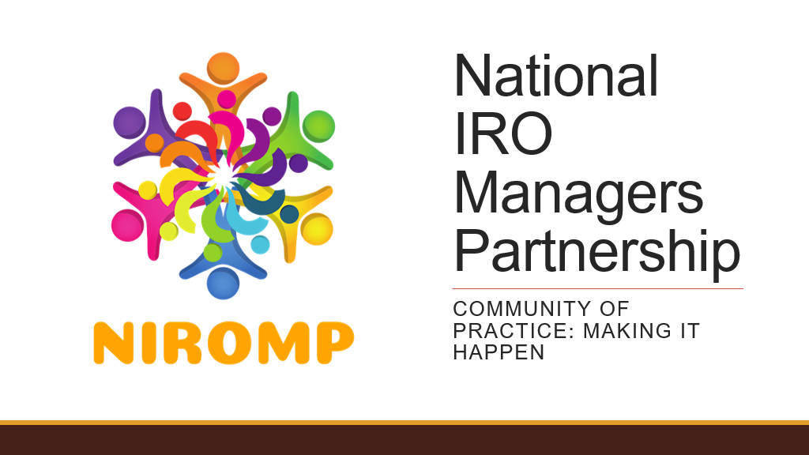

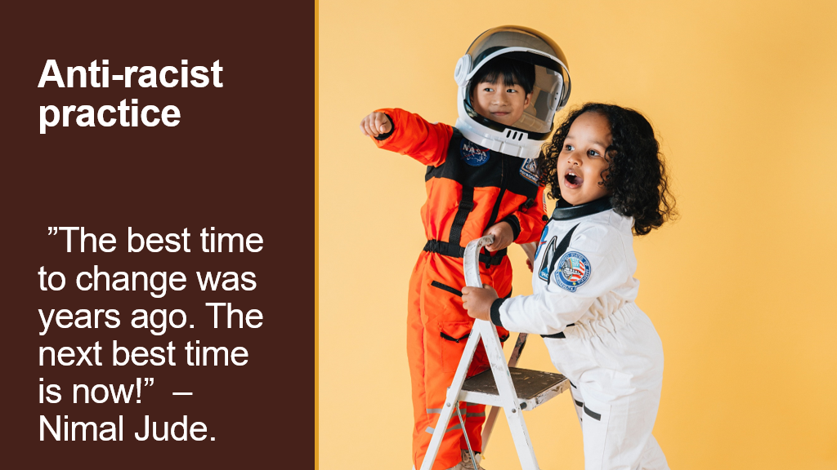

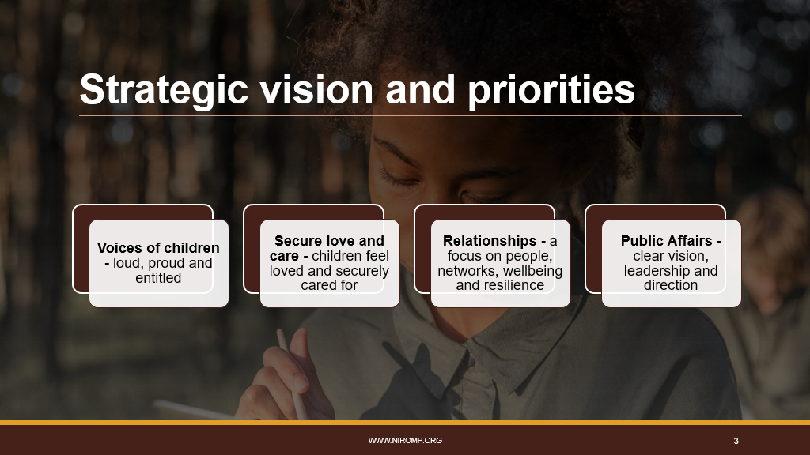

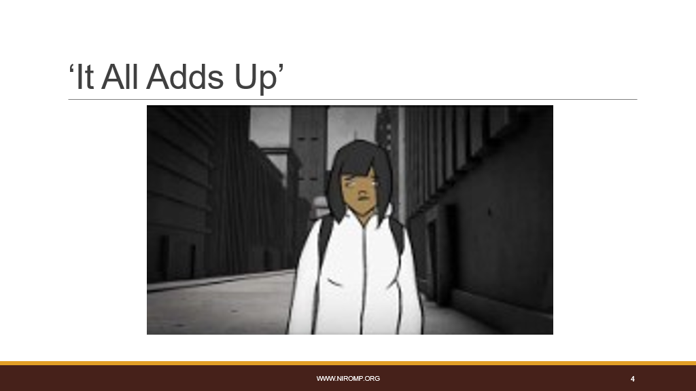
- Leaders Unlocked ‘It All Adds Up’: https://www.youtube.com/watch?v=axzNnGDFpmo
- ‘It All Adds Up’ is an animation created by the Student Commission on Racial Justice a partnership of ‘Leaders Unlocked’ and 10 leading colleges in England. ​
- This 3 minute video is a reminder that racism happens in the everyday for some … and not others … it doesn’t wait for “Black History Month”​
- Care including self-care is important today and everyday. ​
- Breakout groups for 15 mins. What did the film prompt for you? Small groups be prepared for someone to feed back to whole group​
- Back to main group for open floor discussion: what came up in your small groups? What did you notice?​
- Anti-racism work can be overwhelming, uncomfortable, painful and intimidating. It can be easy to become overwhelmed by the slow, apathetic pace of change - a seismic change is needed. ​
- As IROs we should believe in love, justice, integrity and equity for all. Positive anti-racist practice is non-negotiable. ​
​
​ 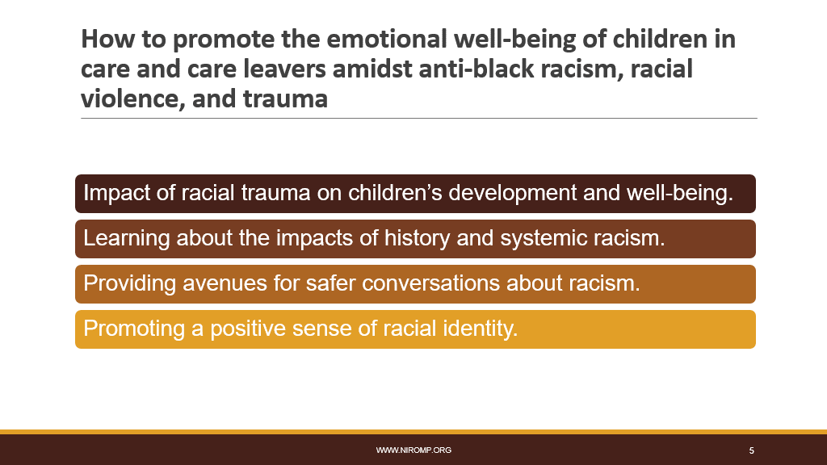

How to support children in care’s emotional well-being amidst anti-black racism, racial violence, and trauma:​
- IROs need to help the people around the child to anticipate the impact of ongoing individual and collective psychological or physical injuries Black and minoritised children can experience due to exposure and re-exposure to race-based adversity, discrimination, and stress, referred to as racial trauma.​
- Exposure to racialised trauma and its impact must inform thinking and planning for the child. For example, when thinking about the child’s education plan / health plan / permanence plan, and so on. Racialised trauma is harmful to children’s development and well-being, so IROs must ensure it is not side-stepped or ignored within care planning and review. ​
- Events that may cause racial trauma include threats of harm and injury, hate speech, humiliating and shaming events, or any other form of individual, historical, or institutional racism and how for example carers are helped to support children with the impact. ​
- Children can also experience racial trauma after hearing about or witnessing another person’s direct experiences, often referred to as secondary traumatic stress or vicarious trauma. To help protect children from the harmful effects of racial trauma, caregivers must start talking to them about race and racism early—when children are very young and first developing a sense of racial identity.​

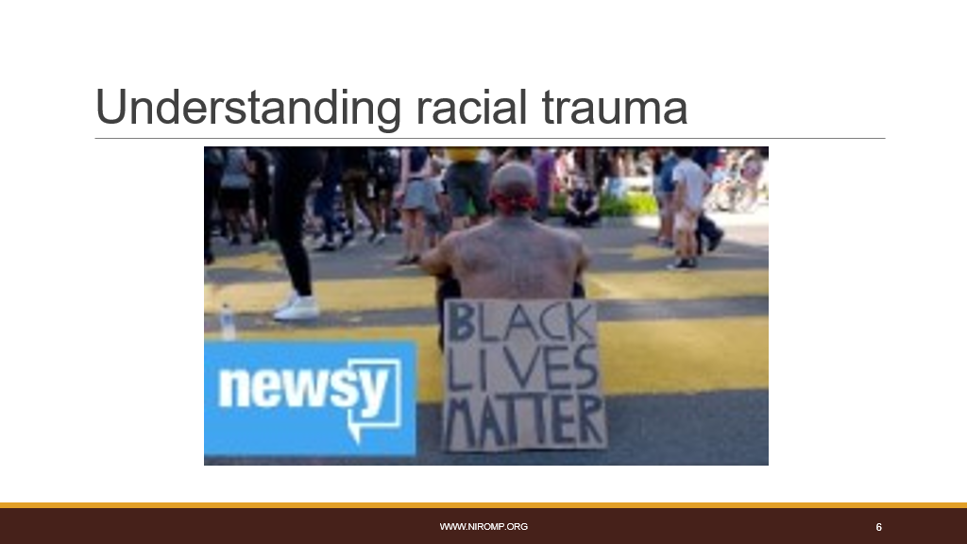
​
​
Understanding racial trauma - 2 min video https://www.youtube.com/watch?v=gIyp8AZV1vs
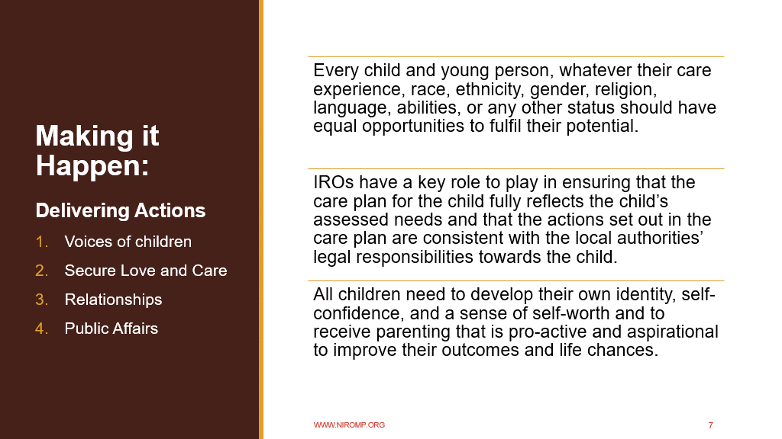

Making it Happen: Delivering Actions​
​
Every child and young person, whatever their care experience, race, ethnicity, gender, religion, language, abilities, or any other status should have equal opportunities to fulfil their potential. ​
​
IROs have a key role to play in ensuring that the care plan for the child fully reflects the child’s assessed needs and that the actions set out in the care plan are consistent with the local authorities’ legal responsibilities towards the child. ​
​
All children need to develop their own identity, self-confidence, and a sense of self-worth and to receive parenting that is pro-active and aspirational to improve their outcomes and life chances.

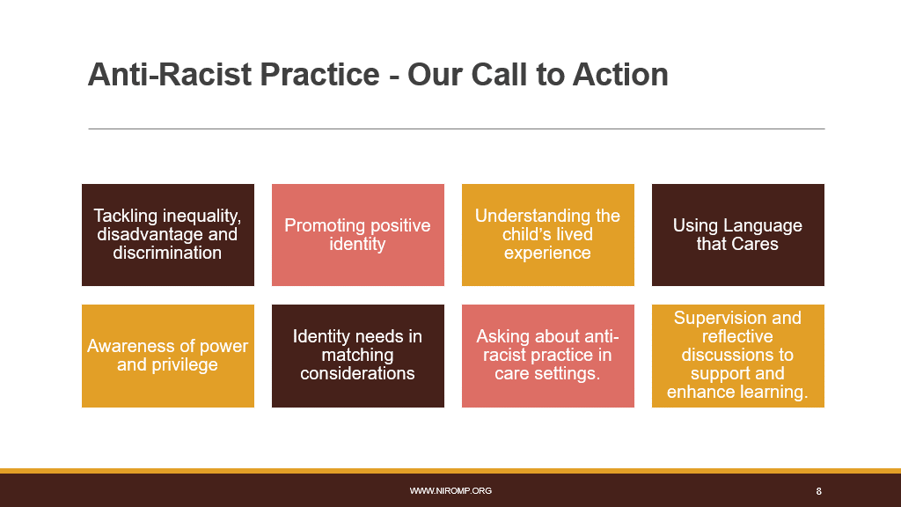

As part of NIROMPs Strategic Priorities the Anti Racism Steering Group, we are calling on all IROs to commit to action and to support this we have collated some practice examples where IROs can influence and support practice. These include:​
- Making sure that due regard is given to the Equality Act 2010 to effectively tackle disadvantage and discrimination.​
- Ensure care planning includes discussion on the promotion of identity and how this will be pro-actively achieved. ​
- Using individual meetings with the child to ask about the child’s lived experience, including where they live, who they see and their day-to-day life and how their sense of self is promoted. Consider when meetings are scheduled to support participation and respecting key events/dates for the child including religious/cultural celebrations.​
- Using Language that Cares within any meetings with the child and the child’s network that pro-actively challenge stereotypes, prejudice, and discrimination. Consider intersectionality and that everyone has their own unique experiences of discrimination and oppression. ​
- Being aware and pro-active in addressing any power imbalances and the impact of discrimination and inequality on the child’s life chances including in assessments, care planning including placement moves, education, health, and family time. Consider the social GGRRAAACCEEESSS model that describes aspects of personal and social identity which afford people different levels of power and privilege.​
- Consider placement choice and matching decisions and how these impacts on a child’s sense of identity, belonging and permanence. Is their identity being promoted positively?​
- Asking about how anti-racist practice is being demonstrated within individual care settings to support all children. Are there positive role models?​
- Being open to learns and adapt. Using supervision and reflective discussions to support and enhance learning.​
​
​
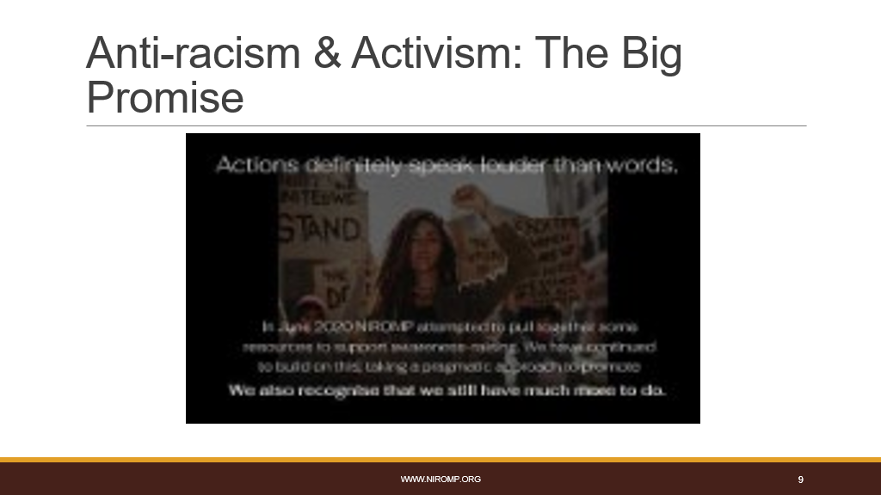

NIROMP ‘The Promise’: https://youtu.be/fxgF8ASNgis

https://youtu.be/fxgF8ASNgisIf we are truly committed to promoting social justice, in society and in relation to the people, families and communities we work with, then we must address racial discrimination. We must show commitment in our every day actions, in our thinking, in our conversations – with family, friends, and colleagues. This includes reporting racist incidents when they occur; calling out racist propaganda and forging alliances to tackle key issues; raising awareness and making suggestions for positive reform.​
​
Our work continues …​
​
​Link to lots of https://niromp.org/2022/03/27/niromp-anti-racism-and-activism/​
​
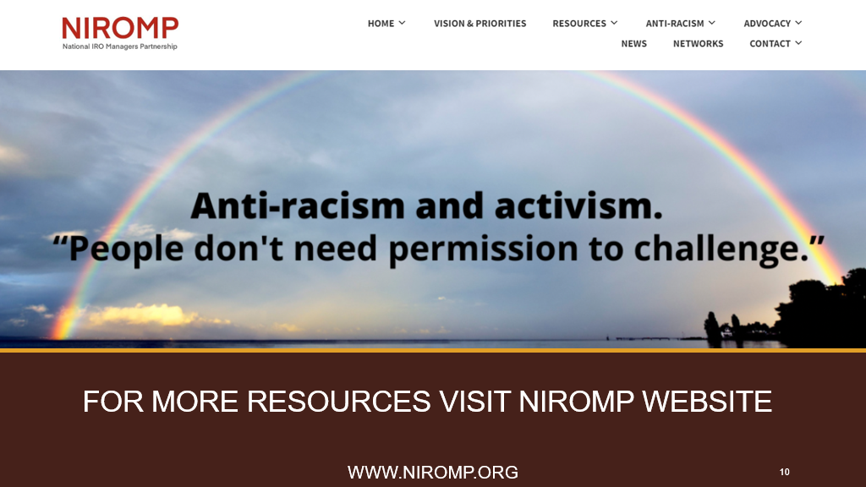

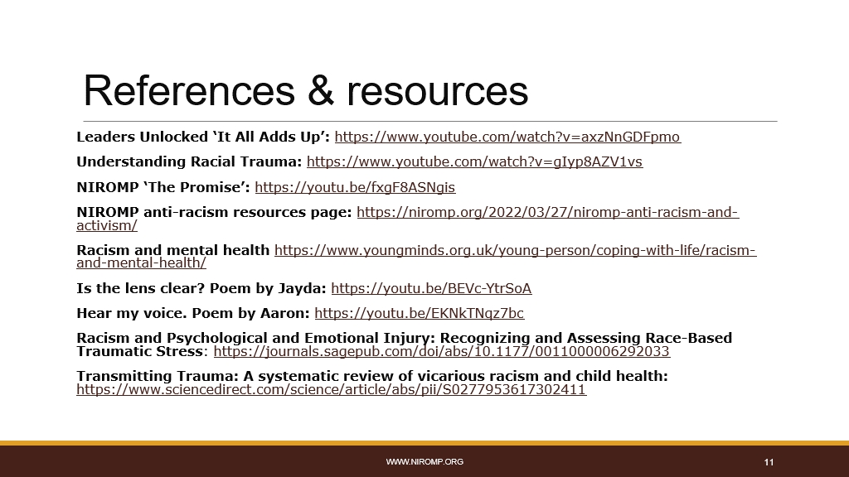

References & resources
Leaders Unlocked ‘It All Adds Up’: https://www.youtube.com/watch?v=axzNnGDFpmo​
Understanding Racial Trauma: https://www.youtube.com/watch?v=gIyp8AZV1vs ​
NIROMP ‘The Promise’: https://youtu.be/fxgF8ASNgis​
NIROMP anti-racism resources page: https://niromp.org/2022/03/27/niromp-anti-racism-and-activism/​
Racism and mental health https://www.youngminds.org.uk/young-person/coping-with-life/racism-and-mental-health/ ​
Is the lens clear? Poem by Jayda: https://youtu.be/BEVc-YtrSoA​
Hear my voice. Poem by Aaron: https://youtu.be/EKNkTNqz7bc​
Racism and Psychological and Emotional Injury: Recognizing and Assessing Race-Based Traumatic Stress: https://journals.sagepub.com/doi/abs/10.1177/0011000006292033​
Transmitting Trauma: A systematic review of vicarious racism and child health: https://www.sciencedirect.com/science/article/abs/pii/S0277953617302411

